Que 1) Plot a histogram,

10, 13, 18, 22, 27, 32, 38, 40, 45, 51, 56, 57, 88, 90, 92, 94, 99 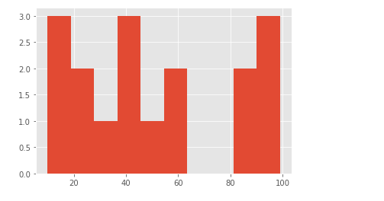

Que 2) In a quant test of the CAT Exam, the population standard deviation is known to be 100. A sample of 25 tests taken has a mean of 520. Construct an 80% CI about the mean.

Ans : SD - 100, n = 25, x̅ = 520

80 % , Significance value - 0.2 ( 0.1 , 0.1)

C.I - Point Estimate +- Margin of Error

Z ($α/2)$ = (z 0.1) = (1-0.1) i.e 0.9 = 1.29

C.I = 520 + 1.29 ( 100/25√) = 520 + 1.29\* 20 = 545.8

520 - 1.29 ( 100/25√) = 520 - 1.29\* 20 = 494.2

The C. I is 494.2 and 545.8

Que 3) A car company believes that the percentage of citizens in city ABC that owns a vehicle is 60% or less. A sales manager disagrees with this. He conducted a hypothesis testing surveying 250 residents & found that 170 residents responded yes to owning a vehicle.

1. State the null & alternate hypothesis.
2. At a 10% significance level, is there enough evidence to support the idea that vehicle owner in ABC city is 60% or less.

Ans: This is a one tail test

Null hypothesis is <= 60 %

Alternative Hypothesis > 60%

Significance level : 0.1

N = 250

Q0 = 1- p0 = 1 - 0.6 = 0.4

$\hat{p}$ = 170/250 = 0.68

Z test with proportion with α = 0.1 in one tail test it will be 1.28

Z test = (0.68 - 0.6) / $\sqrt{(0.6 * 0.4)/250}$ = 0.08 / 0.03 = 2.58

When we draw a normal distribution it is a right one tailed test . Hence as 2.58 > 1.28 . We reject the Null hypothesis as null hypothesis says that it is less than 60%.

Hence, the sales manager is correct regarding the number of people owning cars is more than 60 %.

Que 4) What is the value of the 99 percentile?

2,2,3,4,5,5,5,6,7,8,8,8,8,8,9,9,10,11,11,12

And : 99/100 \* 21 = 20.79 index

99 percentile is 12.

Que 5) In left & right-skewed data, what is the relationship between mean, median & mode?

Draw the graph to represent the same.

Ans - In right skewed : Mean > Median > Mode

In left skewed : Mean < Median < Mode

Right skewed 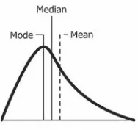 Left Skewed 